Underwater Vehicle Demo Requirements

Goal: demonstrate the development workflow for an autonomous underwater vehicle
This document outlines the high-level requirements for an underwater vehicle in order to illustrate how a similar team would map requirements into their Model-Based Design. The result will demonstrate how a digital thread can link requirements outlined in Microsoft Word all the way through to automatically generated code that would run on embedded hardware.

Mission
The mission for this vehicle is to search for a “black box” acoustic beacon on seafloor, navigate toward it, take a photo of the area to bring to surface, and report back with data on its estimated location
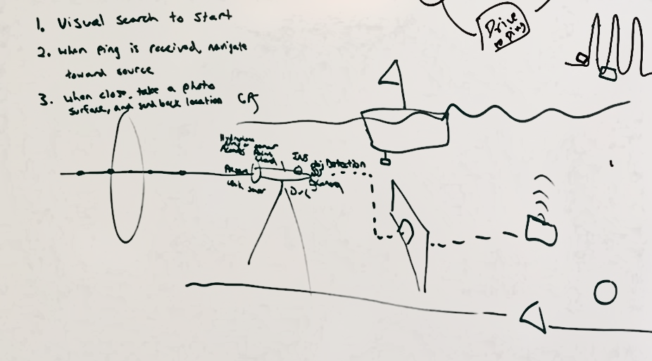
Figure 1: Whiteboard sketch of mission

Functional Requirements

Sensing

The system shall be capable of processing a combination of on-board sensors to estimate the pose of the underwater platform using either active or passive means

The system shall have on-board sensors capable of passively detecting an acoustic beacon signal

The system shall have onboard sensors capable of detecting obstacles in the underwater vehicle’s direct path

The system shall be capable of receiving commands from and communicating with an acoustic command system

Perception

The platform shall create, in real-time, an understanding of the underwater environment, including…

Bathymetry map of the sea floor

An understanding of the ocean currents

The existence and location of any solid obstacles in the direct path of the underwater vehicle

If an underwater acoustic beacon is detected, the system shall be capable of estimating the position of the beacon relative to the underwater vehicle platform in local (e.g. North, East, Down) coordinates

If an underwater acoustic beacon is detected, the system shall be capable of estimating the position of the beacon in global (e.g., earth-centered, earth-fixed) coordinates via acoustic signal

The platform shall be capable of tracking the estimated position of the acoustic beacon over time

The system shall determine whether the beacon is visually apparent if imagery is available

Planning

The system shall be capable of using its understanding of the underwater vehicle platform pose and the environment to create an initial search pattern that minimizes power consumption

When an underwater beacon is detected, the system shall be capable of path planning to navigate toward the beacon, avoiding any perceived obstacles, while minimizing power consumption

The system shall be able to determine whether there is enough power to navigate to the vicinity (10 meters) of the beacon and return to the surface with a predefined threshold of remaining battery

The underwater vehicle shall be capable of planning a navigation path around any obstacles that may be in the area of operation

The system shall be capable of planning a return-to-home path to a predefined user-requested location that minimizes power consumption

Action

The underwater vehicle shall autonomously navigate toward waypoints that are defined by the user or path planning algorithms

The underwater vehicle shall run a search mode pattern until the expected battery level upon return to a designated home point is above a predefined threshold

If a beacon is detected and there is enough power available, the system shall alert the operator and run the Beacon Intercept mission

If a beacon is detected and there is not enough power available to intercept, the system shall alert the operator and wait 10 minutes for a command before executing return-to-home sequence.

The underwater vehicle shall run a Beacon Intercept mode until the expected battery level upon return to a designated home point is above a predefined threshold

Once within camera range, the vehicle shall capture images of the scene and save to on-board storage for visual confirmation upon surfacing

Once there is visual confirmation, the underwater vehicle shall alert the operator of the estimated location of the beacon and execute return-to-home sequence.

Mission Abort

The system shall detect significant deviation from the planned path and if necessary, run return-to-home (RTH) or return-to-surface (RTS) mission abort sequence

When initiated by a hardware fault or failure, the system shall be able to run a return-to-home (RTH) or return-to-surface (RTS) abort sequence. Faults and failures and the sequence they initiate are defined in Table 1.

Table 1: Fault and Failure table and sequences to initiate
Fault/Failure Type | Fault/  Failure | Sequence to Initiate (return to surface or return to home)
Leak | Failure | RTS
10m deviation from path for 30 seconds | Fault | RTH
50m deviation from path for 30 seconds | Failure | RTS
Max Depth Threshold Exceeded | Failure | RTS
Internal temperature HIGH threshold exceeded | Fault | RTH
Internal temperature CRITICAL threshold exceeded | Failure | RTS
Low battery threshold exceeded | Fault | RTH
Critical battery threshold exceeded | Failure | RTS

If requested by the operator, the system shall run a return-to-home (RTH) or return-to-surface (RTS) mission abort sequence

The system shall communicate health and status (estimated location, battery, mode) to the user at a predefined interval when executing a mission abort sequence

